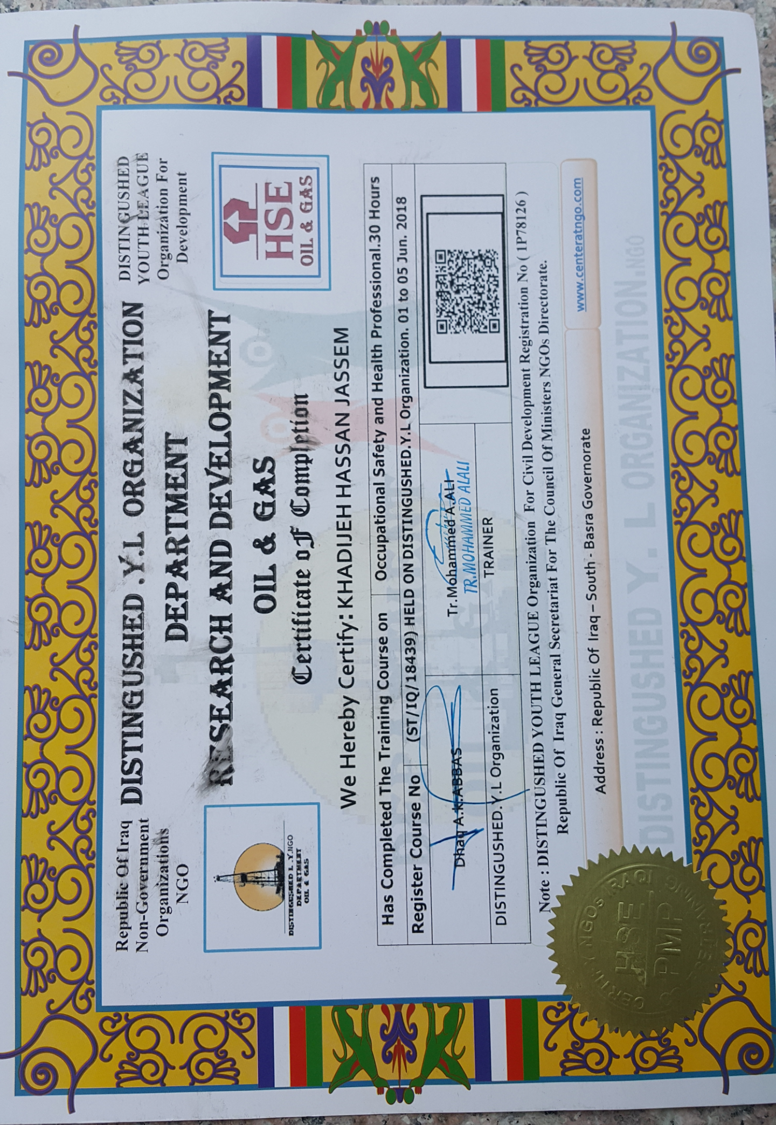

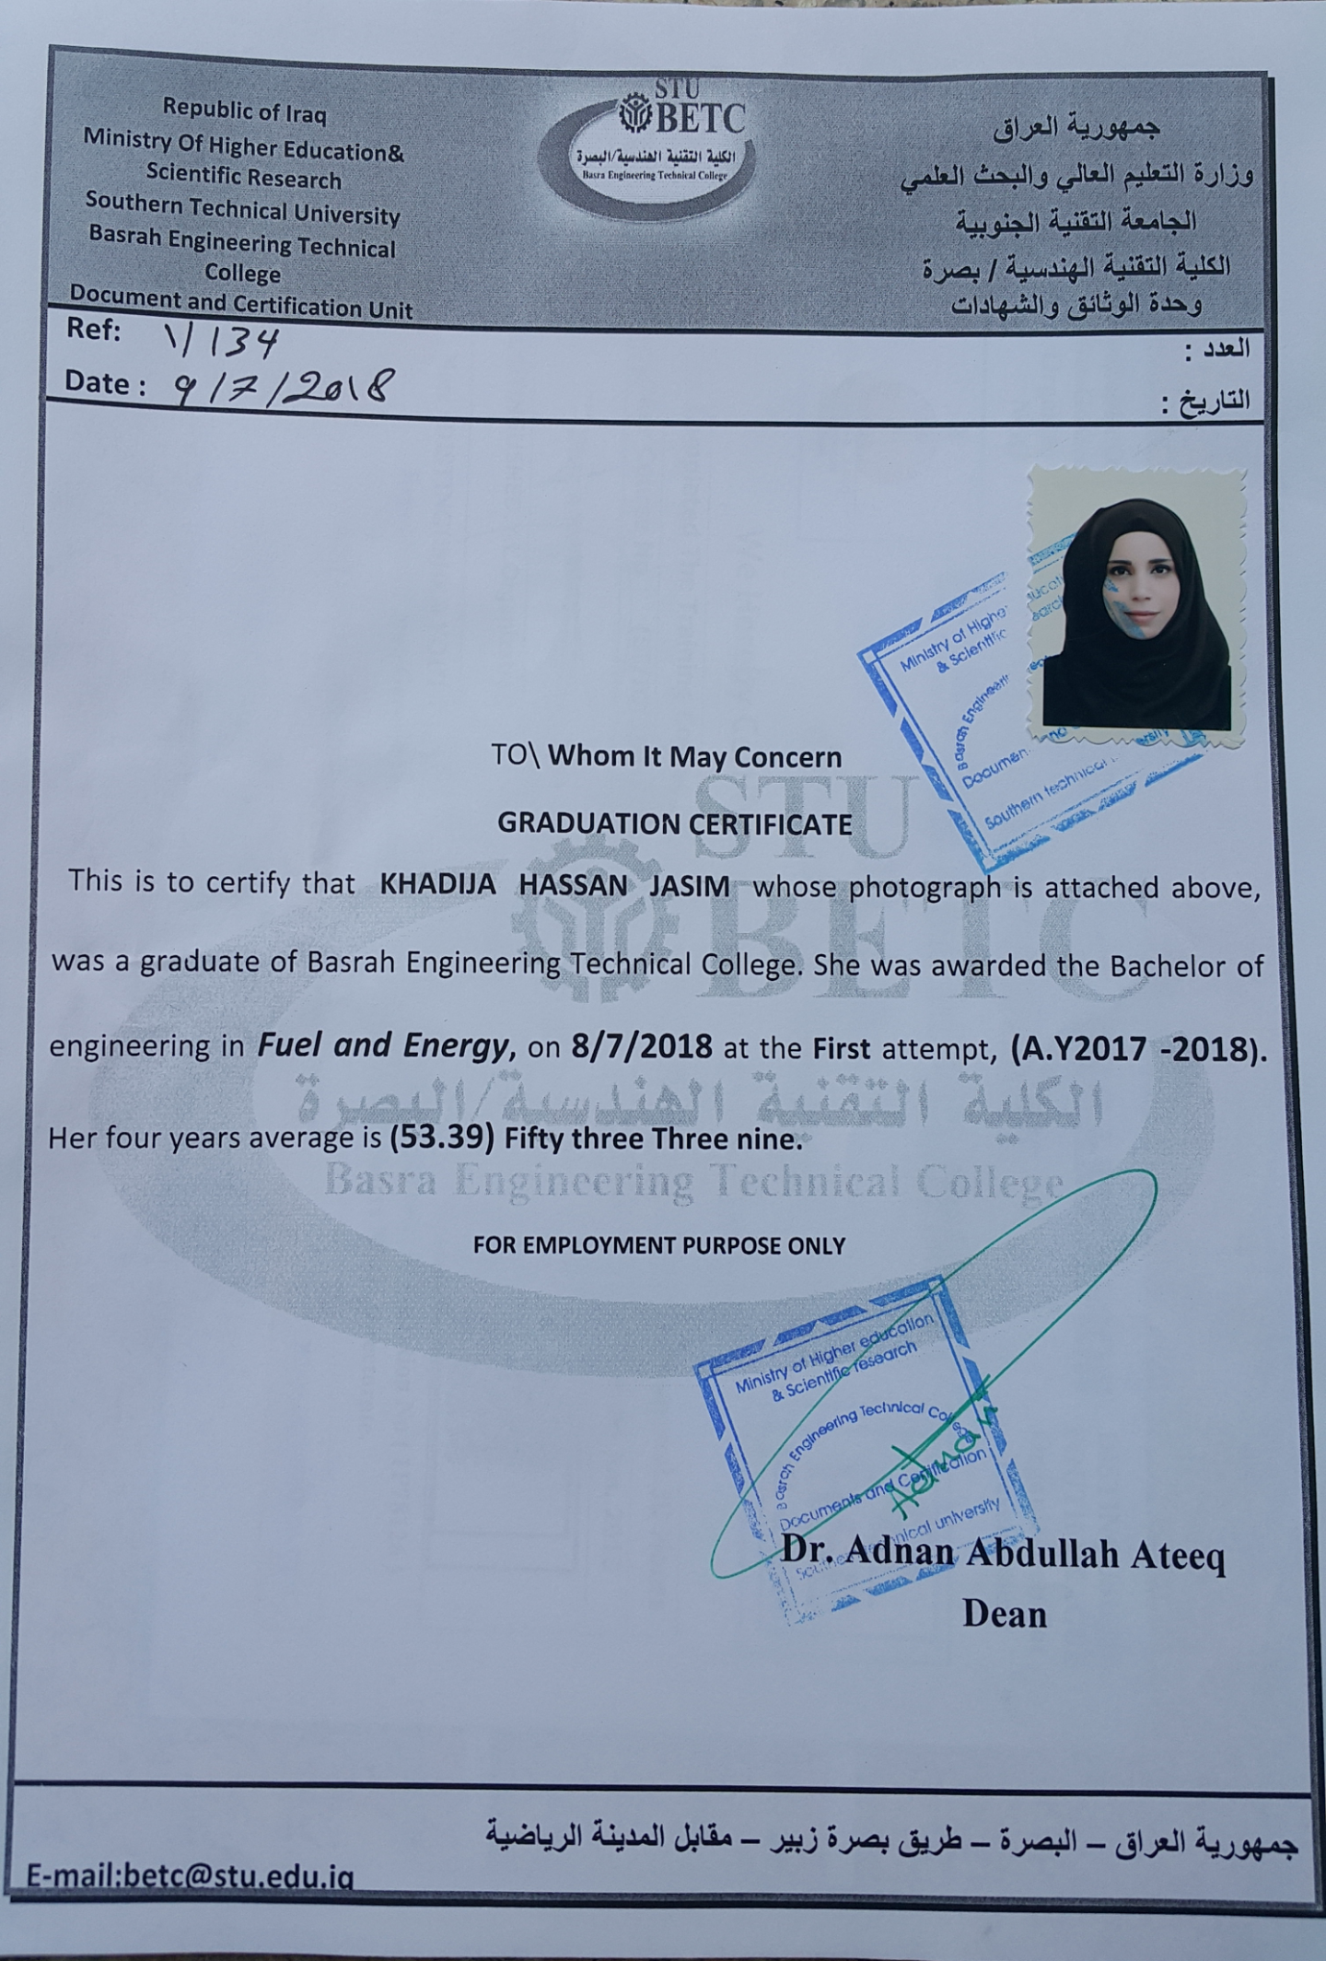

|  |
| --- |
| Khadijeh Hassan  **27 years old ,Born 1991,single,I live in Basra,and Graduate of the College of Engineering and Technology Department of Fuel and Energy .**  **Phone**:07721633652 |
| PERSONAL PROFILE *●* *I have strong management skills with a background in training skills*. **●** *Exceptional ability to lead the**team towards success and reaching project aims*  ●*Prove ability to supervise team member’s performance and monitor progress according to action plan* Education ●Graduated of the Board of Technical Education-The College Technical engineering●Bachelors of Fuel &Engineering●Year of Graduation:2017/2018 OBJECTIVE  Utilizing of my scientific & mentally capabilities to promote the job to the best and higher levels, and managing the mechanical Engineering projects according to the world qualifications and development principles.  Key skills  Advancement, Motivation upon work, organization and leadership | COMPUTER SKILLS  * Computer and Internet professional user * Email & outlook * Microsoft (word, PowerPoint, axel , access) * Programming languages ( Visual basic , Matlab ) * AutoCAD  LANGUAGES  * Arabic: Excellent in written and oral skills * English: good in written and oral skills  TRAINING AND CERTIFICATION  * HSE OIL & GAS * COMPUTER OPERATOR * Bachelor of Fuel Technology and Energy    AWARD  * Al-Ghary Institute for Studies and Research in Al-Twaisa  . |